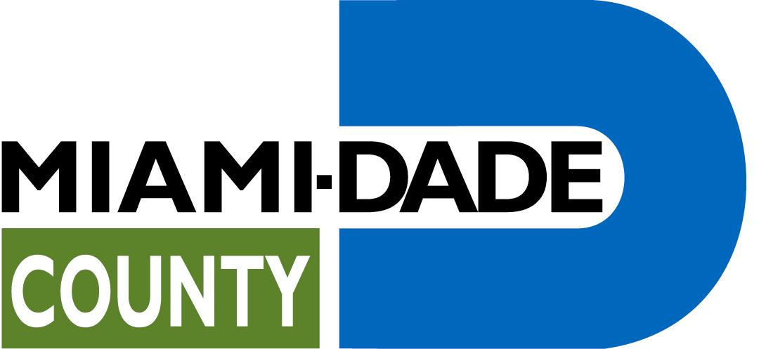

Office of Management and Budget
Grants Coordination
111 N.W. 1st Street,
19th Floor
Miami, FL 33128
305-375-4742 O 305-375-4454 F

miamidade.gov

Carlos A. Gimenez, Mayor

DATE: July 29, 2013

TO: Prospective Proposers

FROM: Theresa Fiaño, Contracting Officer

SUBJECT: RFP No. 1013 – Environmental Education Services Community-Based Organization Funding

PROPOSAL
SUBMISSION DEADLINE: 4:00 P.M., Monday, August 5, 2013

FORMAL ADDENDUM No. 2

This Addendum is hereby made a part of the Request for Proposals (RFP) No. 1013 for Environmental Education Services Community-Based Organization Funding.
Item 1. Clarification of Questions Received:
Questions may have been edited for clarity.

Q. Do applicants have to be 501(c)3 organizations?
A. As stated in the RFP, on pages 1 and 4, and as confirmed by our Assistant County Attorney Estephanie Resnick, “Eligibility to apply for CBO funding is limited to 501(c)3 non-profit organizations. An IRS letter of determination of 501(c)3 status dated prior to the RFP submission deadline must be included as part of the agency’s proposal submission. Include this documentation as directed in Section 8.0 of this RFP. Failure to satisfy this requirement will render the proposal as non-responsive.”

Q. Can I please get a copy of the sign-in sheets from the Pre-Proposal Conference?
A. Yes, please see PDF attachment.

Item 2: Correction to RFP

On page 25 it mistakenly says that the due date for the RFP submission is “…before 4:00 pm on Thursday, July 25, 2013.” The CORRECT submission deadline is 4:00 pm on Monday, August 5, 2013.

