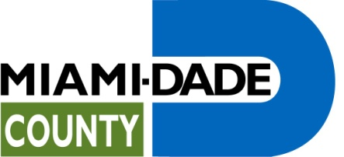

COVER SHEET AND CHECKLIST
(Complete one Cover Sheet for the Entire Application Proposal Package)

Certification of eligibility to apply to Miami-Dade County, for FY 2011-12 Human and Social Services Community-Based Funding RFP

APPLICATION FOR FY 2011-12 HUMAN AND SOCIAL SERVICES
CBO FUNDING RFP No. 0411
Name of Agency:
Federal Tax ID Number:
Street Address:
(Street, City, State, Zip)
Mailing Address (if different):
(Street, City, State, Zip)
Agency Phone:
Agency Fax:
Authorized Officer or Director:
Email address:
Priority Service Area
Service Category |  | Program |  |  | Amount Requested
FY 2011-12 Human and Social Services Community-Based Funding RFP No. 0411

Please check the appropriate response for each to the following questions; then complete the certification at the end.

- Is your agency located in Miami-Dade County?

YES NO

- Please select the one option that best describes the size of your organization. Small agencies are defined as having an annual operating budget of $500,000 or less.

SMALL LARGE

- Have you included documentation of your budget organization’s annual operating budget?

YES NO

- Does your agency comply with the requirement that recipients of financial assistance not be discriminated against for any reason, including, but not limited to race, family status, color, religion, national origin, handicap (disability) or age?

YES NO

- Does your agency provide services within Miami-Dade County?

YES NO

- Have you attached an IRS letter of determination documenting your organization’s status as a 501(c)(3)?

YES NO

I also certify that all of the information contained in this application is true and accurate. I understand that material omission or false information contained in this application constitutes grounds for disqualification of the Applicant(s) and this application. I further understand that by submitting an application I, as an authorized representative of the organization, am accepting the terms and conditions as they appear on the RFP.

_____________________________________ ______________________________
Signature Title

_____________________________________ ______________________________
Print Name Date

_____________________________________
Agency Name

Corporate Seal
Miami-Dade County, FL

