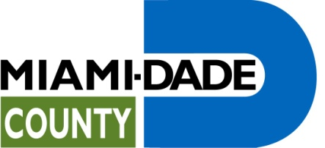

COVER SHEET AND CHECKLIST
(Complete one Cover Sheet for the Entire Application Proposal Package. Attach additional pages as necessary based on the number of individual program requests)

Certification of eligibility to apply to Miami-Dade County, for FY 2015-16 Human and Social Services Community-Based Funding RFP

APPLICATION FOR FY 2015-16 HUMAN AND SOCIAL SERVICES
CBO FUNDING RFP No. CBO1516
Name of Agency:
Federal Tax ID Number:
Street Address:
(Street, City, State, Zip)
Mailing Address (if different):
(Street, City, State, Zip)
Agency Phone:
Agency Fax:
Official Applicant Contact Person:
Email address:
Priority Service Area |  | Program Name |  |  | Amount Requested
FY 2015-16 Human and Social Services Community-Based Funding RFP No. CBO1516

Please check the appropriate response for each to the following questions; then complete the certification at the end.

- Is your agency located in Miami-Dade County?

YES NO

- Is the total amount of funding requested in your application $1 million or less?

YES NO

- Have you included a copies of your IRS Form 990, last certified audit if available or audited/unaudited financial statements, and documentation of your organization’s annual agency-wide operating budget?

YES NO

- Does your agency comply with the requirement that recipients of financial assistance not be discriminated against for any reason, including, but not limited to creed, race, ancestry, family status, color, religion, sexual orientation, gender identity, national origin, familial status, pregnancy, handicap (disability), or age?

YES NO

- Does your agency provide services within Miami-Dade County?

YES NO

- Have you attached an IRS letter of determination documenting your organization’s status as a 501(c)(3)?

YES NO

I also certify that all of the information contained in this application is true and accurate. I understand that material omission or false information contained in this application constitutes grounds for disqualification of the Applicant(s) and this application. I further understand that by submitting an application I, as an authorized representative of the organization, am accepting the terms and conditions as they appear on the RFP.

_____________________________________ ______________________________
Signature Title

_____________________________________ ______________________________
Print Name Date

_____________________________________
Agency Name

Corporate Seal
Miami-Dade County, FL

