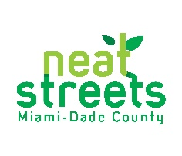
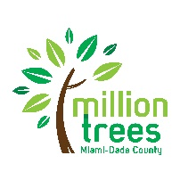
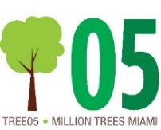
EXHIBIT D:
AMENDMENT CHANGE FORM
2024 GREEN Miami-Dade County Matching Grant

Name of Municipality/Organization:
Name of Project:
Report Submitted By:
Title:
Phone Number:
Email:
Date Submitted:
Amendment Number:

Please ONLY provide information on the elements that you wish to change. For example, if the number of trees to be planted will not be affected by your requested change, there is no need to fill out that row below. For changes to number of trees, tree species, and location of planting, a revised Google Live Map(s) is also required.

Amendment Types:

Grant Award Amount
 | Previously Approved | Requested Change
Grant amount

Please provide an explanation as to why this change is needed:
________________________________________________________________________________________________________________________________________________________________________________________________________________________________________________________________________________________________________________________________________________________________________________________________________________________________________________________________________________________________________________

Time Extension
 | Previously Approved | Requested Change
Project completion date (include new Final Report submission date)

Please provide an explanation as to why this change is needed:
________________________________________________________________________________________________________________________________________________________________________________________________________________________________________________________________________________________________________________________________________________________________________________________________________________________________________________________________________________________________________________

Project Enhancements
 | Previously Approved | Requested Change
Enhancements (Growing Green Bus Stop, Growing Green Playground, Gateway, Corridor, Connections to School and/Parks, Public Lands, Natural Disaster Recovery, Local/Residential Streets)

Please provide an explanation as to why the change is needed:
________________________________________________________________________________________________________________________________________________________________________________________________________________________________________________________________________________________________________________________________________________________________________________________________________________________________________________________________________________________________________________

Trees (Species, Location, Size) – please add lines as necessary; please use one line per tree
Approved Address/Location | Approved Species | Approved Height of Tree | New Location Proposed | New Species Proposed | New Height of Tree Proposed
e.g. 123 SW 67th Ave. | Live oak | 14 ft. | n/a | Pigeon plum | n/a
e.g. 123 SW 67th Ave. | Live oak | 14 ft. | 456 SW 67th Avenue | n/a | n/a
e.g. 123 SW 67th Ave. | Live oak | 14 ft. | n/a | n/a | 12 ft.

Please provide an updated link to your Google Live Planting Plan that includes a new layer titled Amendment 1 to show the proposed changes: _________________________________

Please provide an explanation as to why the change is needed:
________________________________________________________________________________________________________________________________________________________________________________________________________________________________________________________________________________________________________________________________________________________________________________________________________________________________________________________________________________________________________________

Trees (Quantity) –

Approved Tree Count (in contract): ________________________________________________
Proposed Tree Count: ___________________________________________________________

Please add lines as necessary; please use one line per new tree:
New Address/Location Proposed | New Species Proposed | New Height of Trees Proposed

Please provide an updated link to your Google Live Planting Plan that includes a new layer titled Amendment 1 to show the proposed changes: _________________________________

Please provide an explanation as to why the change is needed:
________________________________________________________________________________________________________________________________________________________________________________________________________________________________________________________________________________________________________________________________________________________________________________________________________________________________________________________________________________________________________________

To be filled out by Neat Streets Miami Staff
Impact Statement: _______________________________________________
____________________________________________________________
Decision/Recommended Change by GREEN Miami-Dade County Matching Grant Selection Committee, if necessary: ___________________________________________________________________________
Amendment Change Form Status: Approved:___________________________________
Not Approved:________________________________

